**challenges**

Great question! If you're asked about challenges, you faced while creating or using Dynatrace dashboards, it's a good opportunity to show your problem-solving skills and technical depth.

Here are some realistic challenges you can mention, along with how you addressed them:

🧩 Sample Answer: Challenges Faced

“One challenge I faced was identifying the right metrics among the many available in Dynatrace. For example, there are multiple CPU-related metrics, and I had to experiment to find the one that best reflected actual usage across hosts.

Another challenge was visual clutter — when I added too many tiles, the dashboard became hard to read. I solved this by grouping related metrics and using filters and smart naming conventions.

I also ran into issues with data granularity. Some metrics were too detailed or too aggregated, depending on the time window. I had to adjust the resolution and time range to get meaningful insights.

Lastly, aligning the dashboard with team needs was important. I gathered feedback from developers and SREs to make sure the dashboard was actionable and not just informative.”

Here’s a version of the **challenges faced** answer tailored specifically for an **SRE (Site Reliability Engineer)** role:

**🧩 Sample Answer: Challenges Faced (SRE Perspective)**

“As an SRE, one of the main challenges I faced while building Dynatrace dashboards was ensuring the metrics were not just informative but also **actionable**. For example, I initially included too many system-level metrics, which made it hard to correlate them with service-level objectives (SLOs). I had to refine the dashboard to focus on metrics that directly impacted reliability, like CPU saturation during deployment windows or memory leaks over time.

Another challenge was **balancing granularity and performance**. High-resolution data was useful for debugging, but it increased dashboard load times and made trend analysis harder. I addressed this by using adaptive time windows and aggregations.

I also had to ensure the dashboard supported **incident response workflows**. That meant integrating it with alerting rules and tagging strategies so that during an outage, we could quickly filter by impacted services or hosts.

Lastly, aligning the dashboard with **SLIs and SLOs** was critical. I worked with developers to map infrastructure metrics to service health indicators, which helped us make better decisions during postmortems and capacity planning.”

Great! Here are some **common SRE interview questions** along with **sample answers** to help you prepare effectively:

**🔥 1. How do you handle incident response?**

“During an incident, I follow a structured approach: detect, triage, mitigate, and communicate. I use monitoring tools like Dynatrace or Prometheus to detect anomalies, then assess impact and severity. I prioritize mitigation — even if it's a temporary fix — to restore service quickly. Throughout, I keep stakeholders informed via Slack or incident channels. After resolution, I lead or contribute to a blameless postmortem to identify root causes and preventive actions.”

**📊 2. How do you define and use SLIs, SLOs, and error budgets?**

“SLIs are the metrics that reflect service health — like latency, availability, or error rate. SLOs are the targets we set for those metrics, such as 99.9% availability over 30 days. Error budgets represent the allowable margin of failure. If we exceed the budget, we pause risky deployments and focus on reliability. This framework helps balance innovation and stability.”

**🧰 3. What tools do you use for observability and why?**

“I’ve worked with Dynatrace, Prometheus, Grafana, and ELK stack. Dynatrace is great for full-stack visibility and AI-driven root cause analysis. Prometheus is excellent for custom metrics and alerting. I choose tools based on the environment — for example, Dynatrace for enterprise apps and Prometheus for Kubernetes workloads.”

**🧠 4. Describe a time you improved system reliability.**

“In one project, we had frequent memory-related crashes. I used Dynatrace to analyze memory usage trends and found a leak in a background job. After fixing it and adding memory alerts, crashes dropped by 90%. I also added a dashboard to monitor memory usage across services, which helped prevent future issues.”

Absolutely! Here are several **real-world use cases** for Dynatrace dashboards, especially relevant to SREs and DevOps teams:

**📈 1. Application Performance Monitoring (APM)**

* **Use Case**: Monitor response times, throughput, and error rates of key services.
* **Why it matters**: Helps detect performance degradation before it impacts users.
* **Metrics**: Service response time, request count, failure rate, Apdex score.

**🧪 2. Deployment Validation**

* **Use Case**: Track system health before and after a deployment.
* **Why it matters**: Quickly identify regressions or performance drops.
* **Metrics**: CPU/memory usage, error rates, latency spikes, service restarts.

**🔔 3. Alert Triage Dashboard**

* **Use Case**: Centralize alerts and related metrics for faster incident response.
* **Why it matters**: Reduces mean time to detect (MTTD) and resolve (MTTR).
* **Metrics**: Active problems, impacted services, alert severity, root cause indicators.

**🌐 4. Synthetic Monitoring Overview**

* **Use Case**: Monitor availability and performance of web apps from different geographies.
* **Why it matters**: Ensures global users have a consistent experience.
* **Metrics**: Synthetic test success rate, response time, location-based performance.

**🧠 5. Anomaly Detection & AI Insights**

* **Use Case**: Visualize anomalies detected by Dynatrace Davis AI.
* **Why it matters**: Helps proactively address issues before they escalate.
* **Metrics**: Anomalous CPU/memory usage, unusual traffic patterns, Davis-detected root causes.

**🏗️ 6. Kubernetes or Container Monitoring**

* **Use Case**: Monitor pod health, resource usage, and scaling behavior.
* **Why it matters**: Ensures containerized workloads are running efficiently.
* **Metrics**: Pod restarts, CPU/memory limits, node health, container logs.

**🧾 7. SLA/SLO Compliance Tracking**

* **Use Case**: Track service-level objectives and error budgets.
* **Why it matters**: Ensures reliability targets are met and helps prioritize work.
* **Metrics**: Availability %, latency percentiles, error budget burn rate.

Great question! If you're building a more **advanced APM dashboard** in Dynatrace, here are some **advanced metrics** you can add to gain deeper insights into application behavior and performance:

**🚀 Advanced Metrics for APM Dashboards**

**🔍 1. Service Method Hotspots**

* **Metric**: Method execution time (top methods)
* **Use Case**: Identify slow or frequently called methods within services.
* **Why it matters**: Helps pinpoint performance bottlenecks in code.

**🧵 2. Service Flow and Dependencies**

* **Metric**: Service call count by dependency
* **Use Case**: Visualize upstream/downstream service interactions.
* **Why it matters**: Understand how service dependencies impact performance.

**🧠 3. Davis AI Anomalies**

* **Metric**: Anomalous service behavior (CPU, memory, response time)
* **Use Case**: Highlight metrics flagged by Dynatrace’s AI engine.
* **Why it matters**: Proactive detection of unusual patterns.

**📉 4. Garbage Collection Time**

* **Metric**: GC suspension time or GC count
* **Use Case**: Monitor JVM or .NET memory management.
* **Why it matters**: High GC time can cause latency spikes.

**🌐 5. Web Request Breakdown**

* **Metric**: Web request time by domain or resource type
* **Use Case**: Analyze frontend performance (e.g., JS, CSS, images).
* **Why it matters**: Helps optimize user experience and page load times.

**🧪 6. Custom Business Metrics**

* **Metric**: Custom events or counters (e.g., login failures, cart abandonments)
* **Use Case**: Track business KPIs alongside technical metrics.
* **Why it matters**: Aligns technical health with business impact.

**📦 7. Queue or Thread Pool Metrics**

* **Metric**: Thread pool usage, queue length
* **Use Case**: Monitor backend processing capacity.
* **Why it matters**: Prevents thread starvation and request timeouts.

**🔄 8. Retry and Timeout Rates**

* **Metric**: Retry count, timeout errors
* **Use Case**: Detect instability in service communication.
* **Why it matters**: High retries often indicate downstream issues.

Setting up **Kubernetes monitoring in Dynatrace** involves integrating your Kubernetes cluster with Dynatrace so it can automatically discover and monitor your nodes, pods, containers, and workloads. Here's a step-by-step guide:

**🚀 Step-by-Step: Set Up Kubernetes Monitoring in Dynatrace**

**✅ 1. Prerequisites**

* A running Kubernetes cluster (e.g., EKS, AKS, GKE, or self-managed).
* Access to your Dynatrace environment.
* kubectl configured to access your cluster.

**🧩 2. Install the Dynatrace Operator**

Dynatrace uses the **Dynatrace Operator** to deploy OneAgent and manage monitoring.

**a. Get the installation command:**

1. In Dynatrace, go to **Deploy Dynatrace** > **Kubernetes**.
2. Select your Kubernetes platform.
3. Follow the guided steps to generate the kubectl command.

**b. Apply the command:**

kubectl apply -f https://<your-dynatrace-install-url>

This installs the Dynatrace Operator and sets up the necessary components.

**🧠 3. Configure Monitoring Settings**

* The Operator will deploy **OneAgent** as a DaemonSet to monitor nodes and containers.
* It also deploys **ActiveGate** (optional) for Kubernetes API integration and cloud-native monitoring.

**📊 4. Verify the Setup**

* In Dynatrace, go to **Kubernetes** under **Infrastructure**.
* You should see your cluster, nodes, namespaces, workloads, and pods.
* Metrics like CPU, memory, pod restarts, and container health will be visible.

**📈 5. Create Kubernetes Dashboards**

You can now create dashboards to monitor:

* Node resource usage
* Pod health and restarts
* Namespace-level metrics
* Cluster capacity and saturation

Use the **“Kubernetes”** tile category in the dashboard editor to add relevant charts.

**🔐 6. (Optional) Enable Security Context Monitoring**

* Dynatrace can also monitor container security contexts and vulnerabilities.
* This requires enabling **Cloud Application Security** features.

AKS nodes.

CPU usage

Memory usage

**Disk usage**

AKS pods

**API Average response time**

**API Success Calls 2 hours**

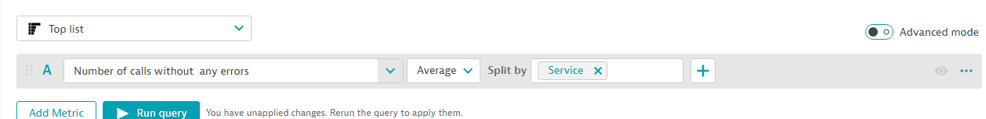

**API Errors**

**Out of Memory Contains**

**Sure! Here's a concise overview of Kubernetes, especially useful if you're preparing for interviews or trying to understand how it fits into monitoring with Dynatrace:**

**☸️ What is Kubernetes?**

**Kubernetes (often abbreviated as K8s) is an open-source platform for automating deployment, scaling, and management of containerized applications.**

**🧱 Core Concepts**

| **Component** | **Description** |
| --- | --- |
| **Pod** | **The smallest deployable unit in Kubernetes. A pod can contain one or more containers.** |
| **Node** | **A physical or virtual machine that runs pods.** |
| **Cluster** | **A set of nodes managed by Kubernetes.** |
| **Deployment** | **Manages the desired state of pods (e.g., how many replicas).** |
| **Service** | **Exposes a set of pods as a network service.** |
| **Namespace** | **Logical partitioning of resources within a cluster.** |
| **ConfigMap & Secret** | **Used to manage configuration and sensitive data.** |

**⚙️ Why Use Kubernetes?**

* **Scalability: Automatically scale applications up/down based on demand.**
* **Self-healing: Restarts failed containers, replaces and reschedules them.**
* **Load balancing: Distributes traffic across healthy pods.**
* **Rolling updates: Deploy new versions of applications without downtime.**
* **Resource efficiency: Optimizes usage of CPU and memory.**

**📊 Kubernetes Monitoring with Dynatrace**

**Dynatrace provides:**

* **Automatic discovery of clusters, nodes, pods, and workloads.**
* **Real-time metrics: CPU, memory, pod restarts, container health.**
* **Service-level insights: Response times, error rates, dependencies.**
* **AI-powered root cause analysis via Davis AI.**

**Would you like a visual diagram of Kubernetes architecture or a cheat sheet for interview prep?**

Thumbnail Image A clean and professional diagram illustrating Kubernetes architecture. Include the following components: 
- A Kubernetes Cluster containing multiple Nodes
- Each Node running multiple Pods
- Each Pod containing one or more Containers
- A Control Plane with components like API Server, Scheduler, Controller Manager, and etcd
- A Service exposing Pods
- Optional: Ingress, ConfigMaps, Secrets, and Persistent Volumes
Use clear labels, arrows to show relationships, and a modern, tech-style design suitable for educational or presentation use.

**3. Dynatrace Kubernetes Monitoring**

* **What it does: Full-stack observability with automatic discovery of Kubernetes components.**
* **Features:**
  + **Visualize nodes, pods, workloads, and services.**
  + **AI-powered root cause analysis.**
  + **Custom dashboards and alerting.**
* **Best for: Enterprises using Dynatrace for APM and infrastructure monitoring.**

**4. Grafana + Prometheus**

* **What it does: Visualize metrics collected from Kubernetes using Prometheus and display them in Grafana dashboards.**
* **Features:**
  + **Custom dashboards for CPU, memory, pod status, etc.**
  + **Alerting and historical data analysis.**
* **Best for: Teams already using Prometheus for monitoring.**

**Here’s a detailed comparison between Dynatrace Kubernetes Monitoring and Grafana + Prometheus, focusing on their strengths, use cases, and differences:**

**⚖️ Dynatrace vs. Grafana + Prometheus**

| **Feature** | **Dynatrace Kubernetes Monitoring** | **Grafana + Prometheus** |
| --- | --- | --- |
| **Setup Complexity** | **Easy (automated via Dynatrace Operator)** | **Moderate to High (manual setup of Prometheus, exporters, Grafana)** |
| **Data Collection** | **Full-stack (infra, apps, services, logs, traces)** | **Primarily metrics (infra and app-level with exporters)** |
| **Visualization** | **Built-in dashboards, AI insights, Smartscape topology** | **Highly customizable dashboards in Grafana** |
| **Alerting** | **AI-powered (Davis AI), anomaly detection, root cause analysis** | **Rule-based alerting via Alertmanager** |
| **Auto-Discovery** | **Automatic discovery of clusters, nodes, pods, workloads** | **Requires configuration and service discovery setup** |
| **AI & Automation** | **Yes (Davis AI for root cause, auto-baselining)** | **No native AI; manual tuning required** |
| **Cost** | **Commercial (licensed per host/unit)** | **Open-source (free), but operational overhead** |
| **Security & Compliance** | **Enterprise-grade, built-in compliance features** | **Depends on configuration and plugins** |
| **Use Case Fit** | **Best for enterprises needing full observability and automation** | **Best for teams wanting open-source, flexible monitoring stack** |

**🧠 When to Choose What?**

**✅ Choose Dynatrace if:**

* **You want end-to-end observability (infra + apps + services).**
* **You need AI-driven insights and automated root cause analysis.**
* **You prefer minimal manual setup and enterprise support.**

**✅ Choose Grafana + Prometheus if:**

* **You want a fully open-source and highly customizable stack.**
* **You’re comfortable managing your own monitoring infrastructure.**
* **You need fine-grained control over metrics and visualizations.**

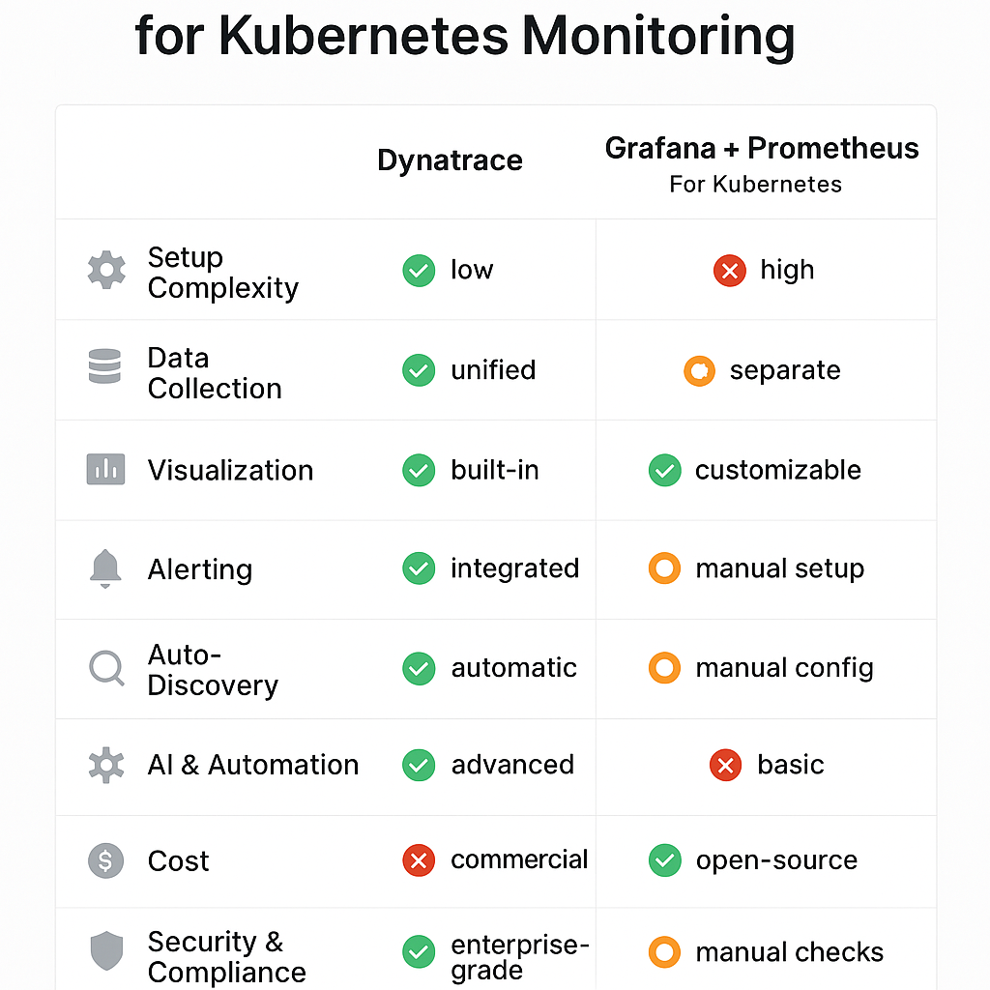

**Here are some best practices for designing effective dashboards, especially in tools like Dynatrace, Grafana, or any observability platform:**

**🎯 1. Define the Purpose First**

* **Know your audience: SREs, developers, executives?**
* **Decide the goal: Monitoring health, debugging, tracking SLOs?**

**📊 2. Prioritize Key Metrics**

* **Show the most important KPIs at the top (e.g., response time, error rate).**
* **Use summary tiles (e.g., single value or status tiles) for quick insights.**

**🧩 3. Group Related Metrics**

* **Organize by:**
  + **Layer (infrastructure, application, user experience)**
  + **Service or namespace**
  + **Environment (prod, staging)**

**🎨 4. Use Visual Hierarchy**

* **Use consistent colors (e.g., red for alerts, green for healthy).**
* **Use larger tiles for critical metrics.**
* **Avoid clutter — whitespace is your friend.**

**🧠 5. Add Context**

* **Use Markdown tiles to explain what each section shows.**
* **Add thresholds and labels to make charts more readable.**

**🔄 6. Make It Dynamic**

* **Use filters (e.g., by host, service, zone) to make dashboards reusable.**
* **Leverage management zones or tags in Dynatrace.**

**📥 7. Share and Iterate**

* **Share with your team and gather feedback.**
* **Regularly review and update dashboards to reflect changing needs.**

**Would you like a visual checklist or a template to help you design your own dashboard layout?**

Thumbnail Image A visual checklist infographic titled 'Best Practices for Dashboard Design'. Include sections with icons and short bullet points: 
1. Define the Purpose
2. Prioritize Key Metrics
3. Group Related Metrics
4. Use Visual Hierarchy
5. Add Context
6. Make It Dynamic
7. Share and Iterate
Use a clean, modern layout with tech-style design, suitable for SREs and DevOps teams.

**Great question! While Dynatrace and Grafana both support dashboard creation, the process, flexibility, and purpose differ significantly. Here's a comparison to help you understand:**

**🧭 Dashboard Creation: Dynatrace vs Grafana**

| **Feature** | **Dynatrace** | **Grafana** |
| --- | --- | --- |
| **Purpose** | **Full-stack observability with AI-driven insights** | **Flexible, open-source visualization for time-series data** |
| **Data Source** | **Built-in (OneAgent, Kubernetes, cloud integrations)** | **Multiple sources (Prometheus, Loki, Elasticsearch, etc.)** |
| **Setup** | **Auto-discovery of metrics and services** | **Manual configuration of data sources and queries** |
| **Chart Creation** | **Uses Data Explorer and Custom Chart Tiles** | **Uses Panels with custom queries (e.g., PromQL, InfluxQL)** |
| **Customization** | **Limited layout control, but smart defaults** | **Highly customizable layouts, themes, and plugins** |
| **Alerting Integration** | **Built-in with Davis AI and problem detection** | **Integrated via Alertmanager or Grafana Alerting** |
| **Ease of Use** | **Easier for beginners, especially in enterprise environments** | **Requires more setup and query knowledge** |
| **Use Case Fit** | **Best for full-stack monitoring with minimal config** | **Best for custom dashboards and open-source flexibility** |

**🧠 Summary:**

* **Dynatrace is great for teams that want automated observability with minimal setup.**
* **Grafana is ideal for teams that want full control and customization over their dashboards and data sources.**

**Would you like a side-by-side visual comparison of dashboard creation in both tools or a hands-on example of creating the same dashboard in each?**

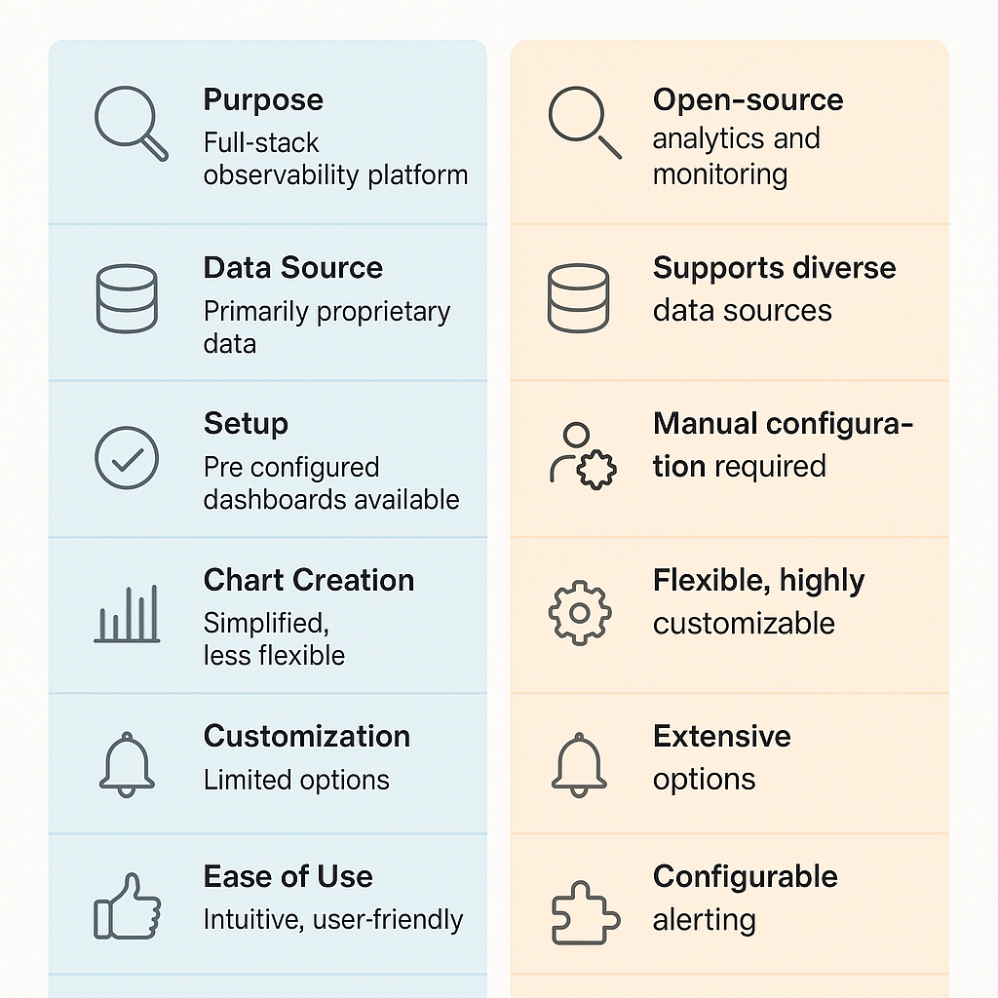

**🚨 How to Create Alerts in Dynatrace**

**✅ 1. Understand Dynatrace Alerting Basics**

Dynatrace uses:

* **Problems**: Automatically detected issues (e.g., high CPU, service failure).
* **Alerting Profiles**: Define when and how alerts are triggered.
* **Notification Integrations**: Where alerts are sent (e.g., email, Slack, Opsgenie).

**🧭 2. Create an Alerting Profile**

1. Go to **Settings** > **Alerting** > **Alerting profiles**.
2. Click **“Create alerting profile”**.
3. Define:
   * **Problem severity levels** (e.g., availability, performance).
   * **Time window** (e.g., only during business hours).
   * **Tag filters** (optional: alert only for specific services or hosts).

**📬 3. Set Up Notification Integration**

1. Go to **Settings** > **Integration** > **Problem notifications**.
2. Click **“Set up notification”**.
3. Choose a channel (e.g., Email, Slack, Microsoft Teams, PagerDuty).
4. Link it to the alerting profile you created.
5. Customize the message format if needed.

**📊 4. Use Custom Events for Alerting (Optional)**

For more control:

* Go to **Settings** > **Anomaly detection** > **Custom events for alerting**.
* Create alerts based on:
  + **Metric thresholds** (e.g., CPU > 90% for 5 minutes).
  + **Log patterns**.
  + **Calculated service metrics**.

**🧠 5. Leverage Davis AI**

* Dynatrace’s **Davis AI** automatically correlates anomalies and reduces alert noise.
* You can view root cause analysis directly in the **Problems** section.

**📌 Best Practices**

* Use **management zones** to scope alerts to specific teams or environments.
* Avoid alert fatigue: tune thresholds and use Davis AI to reduce false positives.
* Test alerts using the **“Send test notification”** feature.

In **Dynatrace**, alerts are typically tied to **problem detection**, and they can be categorized by **severity levels** — which help prioritize incidents. Here's a breakdown of the **critical alert types** you might encounter or configure:

**🚨 Critical Alert Types in Dynatrace**

**1. Availability Problems (Critical)**

* **Examples**: Service or host is down, endpoint unreachable.
* **Why it matters**: Direct impact on user experience or business operations.

**2. Performance Degradation**

* **Examples**: Increased response time, slow database queries, high latency.
* **Severity**: Often marked as **performance** or **slowdown** problems.
* **Why it matters**: Indicates potential bottlenecks or degraded user experience.

**3. Failure Rate Increase**

* **Examples**: Spike in HTTP 5xx errors, failed transactions, service crashes.
* **Severity**: **Error** or **failure**.
* **Why it matters**: May indicate broken functionality or backend issues.

**4. Resource Exhaustion**

* **Examples**: High CPU usage, memory saturation, disk full.
* **Severity**: **Resource** or **infrastructure**.
* **Why it matters**: Can lead to service crashes or degraded performance.

**5. Custom Metric Threshold Breaches**

* **Examples**: Custom SLOs, business KPIs (e.g., login failures > threshold).
* **Severity**: Defined by you.
* **Why it matters**: Tailored to your environment and business logic.

**6. Security Alerts (if enabled)**

* **Examples**: Vulnerabilities in containers, misconfigured security contexts.
* **Severity**: **Security** (requires Application Security module).
* **Why it matters**: Helps prevent breaches and compliance issues.

**🧠 Severity Levels in Dynatrace**

Dynatrace classifies problems by severity:

* **Availability**
* **Error**
* **Performance**
* **Resource**
* **Custom**
* **Security**

Each can be filtered and routed differently using **alerting profiles**.

Would you like a **visual severity matrix** or a **real-world example** of configuring a critical alert for a Kubernetes pod crash or service outage?

Here are the **different types of alerts** you can configure or encounter in **Dynatrace**, categorized by their purpose and source:

**🚨 Types of Alerts in Dynatrace**

**1. Automatic Problem Alerts (AI-Driven)**

* Triggered by **Davis AI** when anomalies are detected.
* Examples:
  + Service response time degradation
  + Host unavailable
  + Increased failure rate
* **Severity levels**: Availability, Error, Performance, Resource

**2. Custom Metric Alerts**

* Based on thresholds you define for any metric.
* Examples:
  + CPU usage > 90% for 5 minutes
  + Disk space < 10%
* Created via:  
  **Settings → Anomaly detection → Custom events for alerting**

**3. Log-Based Alerts**

* Triggered when specific **log patterns** or error messages appear.
* Useful for detecting application-specific issues.
* Created via:  
  **Log Monitoring → Create log event for alerting**

**4. SLO-Based Alerts**

* Triggered when **Service Level Objectives (SLOs)** are breached.
* Examples:
  + Apdex score < 0.85
  + Error budget exhausted
* Created via:  
  **Service-level objectives → Add SLO → Enable alerting**

**5. Security Alerts *(if Application Security module is enabled)***

* Triggered by vulnerabilities or misconfigurations.
* Examples:
  + Vulnerable libraries detected
  + Container running as root

**6. Synthetic Monitoring Alerts**

* Triggered when **synthetic tests** (e.g., browser or HTTP monitors) fail.
* Examples:
  + Login page not loading
  + API endpoint returns 500 error

**7. Availability Alerts**

* Triggered when a service, host, or process becomes unavailable.
* Often considered **critical**.

**8. Third-Party Integration Alerts**

* Alerts forwarded to tools like:
  + Slack, Microsoft Teams
  + PagerDuty, Opsgenie
  + ServiceNow
* Configured via:  
  **Settings → Integration → Problem notifications**

Would you like a **visu** **In Dynatrace, alerts (or problems) are categorized by severity levels, which help prioritize responses. You've already mentioned Warning and Critical, but here's a full list of the alert severity types and what they typically represent:**

**🚨 Dynatrace Alert Severity Levels**

| **Severity** | **Description** |
| --- | --- |
| **🔴 Availability** | **Critical issues like service or host down, endpoint unreachable.** |
| **🟠 Error** | **Increased failure rates, HTTP 5xx errors, failed transactions.** |
| **🟡 Performance** | **Degraded response times, slow services, latency spikes.** |
| **🟣 Resource** | **High CPU, memory saturation, disk full — infrastructure-related issues.** |
| **🔵 Custom** | **User-defined alerts based on custom metrics or thresholds.** |
| **🟤 Security** | **Vulnerabilities, misconfigurations, or risky container behavior (if enabled).** |
| **🟢 Info/Warning** | **Informational or early warning alerts — not immediately critical.** |

**🧠 How These Are Used**

* **You can filter alerts by severity in dashboards or alerting profiles.**
* **Severity levels help route alerts to the right teams (e.g., critical to on-call, warnings to backlog).**
* **Dynatrace’s Davis AI uses these levels to prioritize and correlate problems.**

**Would you like a color-coded visual chart of these severity levels or help setting up alert routing based on severity?**

**al summary** of these alert types or a **real-world example** of setting one up?

Here’s a step-by-step guide to **set up alerting in Grafana**, especially when using **Prometheus** or other data sources:

**🚨 How to Set Up Alerts in Grafana (v9 and above)**

**✅ 1. Create or Open a Dashboard**

* Go to **Dashboards** → Create or open an existing one.
* Add a **Panel** with the metric you want to monitor (e.g., CPU usage, error rate).

**🧪 2. Add an Alert Rule**

* In the panel editor, go to the **“Alert”** tab.
* Click **“Create alert rule”**.
* Define:
  + **Condition**: e.g., avg() of query A is above 90
  + **Evaluation interval**: How often to check the condition
  + **For**: How long the condition must be true before triggering

**📬 3. Set Up Notification Channels**

* Go to **Alerting** → **Contact points**.
* Add a contact point (e.g., Email, Slack, Microsoft Teams, PagerDuty).
* Configure the integration (e.g., webhook URL, credentials).

**🧩 4. Create a Notification Policy**

* Go to **Alerting** → **Notification policies**.
* Define rules for routing alerts:
  + Match labels (e.g., severity = critical)
  + Route to specific contact points
  + Set escalation timing

**🧠 5. Test the Alert**

* Use the **“Test rule”** button in the alert editor.
* Trigger a test alert to verify delivery.

**📌 Best Practices**

* Use **labels** like severity, environment, or service for routing.
* Avoid alert fatigue: set thresholds carefully and use for durations.
* Group alerts by service or team for better triage.

Would you like a **visual flowchart** or a **real-world example** of setting up an alert for high CPU usage in Grafana with Prometheus?

|  |  |
| --- | --- |
| Intro to Dynatrace | Noc can navigate through dyntrace and create dashboard. understanding about application,process, host , services and data centers |
| Dashboards and Data Explore | Noc can create new dashboard for teams based on host,problems,cpu saturated,db health checkserver utilizing etc |
| Hosts and Processes | To detect performance issues and system health anomalies like CPU saturated, memory usage, traffic etc |
| Service |  |
| Application and synthetics |  |
| Anomaly detection |  |
| Log monitoring and DQL |  |
| Host groups, pgs , tags |  |
| alert profiles & notifications |  |
| Dynatrace overview and UI Navigation |  |
| Monitored entities |  |
| Service : flow , backtrace & traces |  |

Creating alerts in **Dynatrace** involves setting up **custom alerts** or **problem detection rules** to monitor specific metrics, thresholds, or anomalies. Here's a step-by-step guide to help you set up alerts:

**🔧 Steps to Create Alerts in Dynatrace**

**1. Log in to Dynatrace**

* Go to your Dynatrace environment URL.
* Use your credentials to log in.

**2. Navigate to Alerting Settings**

* Go to **Settings** > **Anomaly detection** or **Settings** > **Alerting** depending on what you want to monitor.
* You can also go to **Metrics** if you're setting up a custom metric alert.

**3. Choose What to Monitor**

You can create alerts for:

* **Infrastructure metrics** (CPU, memory, disk, etc.)
* **Application performance** (response time, error rate, etc.)
* **Custom metrics** (from OneAgent, APIs, or integrations)

**4. Create a Custom Alert**

* Go to **Settings** > **Anomaly detection** > **Custom events for alerting**.
* Click **Create custom event for alerting**.
* Choose the **metric** you want to monitor.
* Set the **threshold** (e.g., CPU usage > 90% for 5 minutes).
* Define the **scope** (host, service, process group, etc.).
* Set **alert conditions** (static or auto-adaptive thresholds).
* Add **tags** or filters if needed.

**5. Configure Notification Settings**

* Go to **Settings** > **Integration** > **Problem notifications**.
* Add a notification channel (e.g., email, Slack, Microsoft Teams, ServiceNow, etc.).
* Link the alert to the notification channel.

**6. Save and Test**

* Save your alert configuration.
* Optionally, simulate or test the alert to ensure it works as expected.

**✅ Best Practices**

* Use **auto-adaptive thresholds** where possible to reduce false positives.
* Tag your entities (hosts, services) for better alert targeting.
* Use **maintenance windows** to suppress alerts during planned downtimes.
* Regularly review and tune alert thresholds.

Would you like help creating a specific type of alert (e.g., CPU usage, response time, custom metric)? I can guide you through that too.

1. **What do you want to monitor?**  
   (e.g., CPU usage, memory, disk space, response time, error rate, custom metric, etc.)
2. **What is the threshold or condition for the alert?**  
   (e.g., CPU usage > 90% for 5 minutes)
3. **Which entities should this apply to?**  
   (e.g., all hosts, a specific service, a tagged group of hosts, etc.)
4. **Do you want to send notifications?**  
   (e.g., email, Slack, Microsoft Teams, ServiceNow, etc.)